Appendix C: The Unified Modeling Language

Class Diagrams
UML syntax for the attributes (variables) of a class:
[visibility] name [: type] [= defaultValue] [{property}]
Visibility | +  -  #  Default:
name
type
defaultValue
property

UML syntax for the operations (functions) of a class:
[visibility] name [: type] [= defaultValue] [{property}]

Visibility | +  -  #  Default:
name
type
property
parameterList

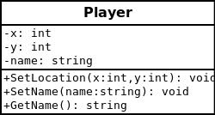
Example:

